The SMBX *.LVL file file description
It is probed by Wohlstand 02/12/2014
(100% done)
This is a level map TEXT file. All parameters are written line by line without blank lines.

Introduction
Standart parameters:
Standart size of one block 32x32 pixels
On screen can showing height 19 blocks
On screen can showing width 25 blocks
Height of screen 608 pixels (non 600, 608: 608/19=32 — one block size)
Width of screen 800 pixels
Max level space size: 419998×419998 pixels (but It is allowed to come out of limits)

Architecture of level
Each level is divided into 21 sections, which can be created "room". All sections are located in the same level space. Levels are displayed on coordinates with the reflected Y:

Level sections

The green squares – is level sections, as rooms:

The maps of rooms defaultly makes in these black squares (21 squares).
Sections won't be crossed.

The Section ranges can have any size and position. Sections may not by crossed:

Superimposing as is considered intersection of sections.
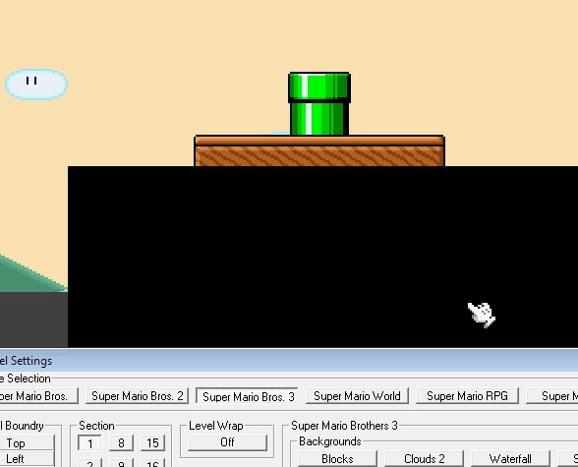
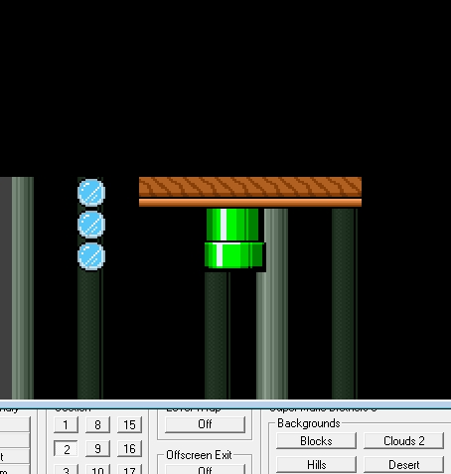
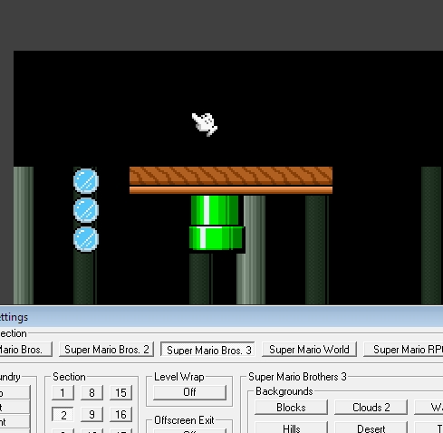
Consequences of inter-crossing of sections:
Default section ranges

(Section Center) Section (X and Y axis ranges)
-200000 01 (-190000 : -219999)
-180000 02 (-170000 : -189999)
-160000 03 (-150000 : -189999)
-140000 04 (-130000 : -149999)
-120000 05 (-110000 : -129999)
-100000 06 (-90000 : -109999)
-80000 07 (-70000 : -89999)
-60000 08 (-50000 : -69999)
-40000 09 (-30000 : -49999)
-20000 10 (-10000 : -29999)
0000 11 (9999 : -9999)
20000 12 (10000 : 29999)
40000 13 (30000 : 49999)
-60000 14 (50000 : 69999)
80000 15 (70000 : 89999)
100000 16 (90000 : 109999)
120000 17 (100000 : 129999)
140000 18 (130000 : 149999)
160000 19 (150000 : 169999)
180000 20 (170000 : 189999)
200000 21 (190000 : 209999)

- Standart size of one section is 29999×29999 pixels
- Y is always equal to X as Section center coordinates
- where x=0 and y=0 – is a center of 11'th section.

For convert from absolute coordinates to the relative of center by one section:

Coordinates of placement of object it is set concerning its upper left corner:
In this example, mushroom coordinates on current section is: X=2150; Y=2600
and block coordinates is: X=2150; Y=2632
Remember!
As the Y axis is turned to move object down, it is necessary to add to Y offset and to move up, it is necessary to subtract.
File Format Specification
Structure
- [header]
- [sections settings]
- [player's start points]
- [blocks on level]
- “next”
- [background tiles]
- “next”
- [NPS's options]
- “next”
- [Warps/Doors options]
- “next”
- [Water/Quicksand]
- “next”
- [Layers]
- “next”
- [Events]

The reference designations:
- standart parameter
- Comment title
- Comment description
- loop
- variable
- Special option, using only under special conditions, differently is absent
- The option isn't known yet
- File format version limit
- Data type

File format version:
The version number of the file format defines data present or absent in the file.

--File begin--
First 3th lines (Header):
Parameter | Description
64 | (unsigned int) File format number (last in SMBX is 64)
0 | (unsigned int) number of stars on this level (>= 17)
"Level name" | (string) Level title (>=62)

Section properties
(loop 21 times) (if <8, loop 6 times)
-200000 | (long) Left size (-left/+right)
-200768 | (long) Top size (-down/+up)
-200000 | (long) Bottom size (full screen is -200600 -down/+up)
-199200 | (long) Right size (full screen is -199200 +left/-right)
24 | (unsigned int) Music number (24 is enable custom music file)
16291944 | (long) Background color (In old versions editors)  [0] = black, [16291944] = blue, [10520656] = dark blue-green
#FALSE# | (bool) Is Level wrap
#TRUE# | (bool) enable Off Screen exit
13 | (unsigned int) Background number
#FALSE# | (bool) No turn back
#TRUE# | (bool) Under water (>=32)
"somefile.mp3" | (string) Custom music file (>=2)
(End loop)

Player start points
-199996 | (long) First player Position x (+left/-right) (0 – player point isn't set)
-200600 | (long) First player Position y (+up/-down) (0 – player point isn't set)
24 | (unsigned int) Width of character (0 – is is first player point isn't set)
54 | (unsigned int) Height of character (0 – is is first player point isn't set)
-199242 | (long) Second player Position x (0 – player point isn't set)
-200068 | (long) Second player Position y (0 – player point isn't set)
24 | (unsigned int) Width of character (0 – is is second player point isn't set)
60 | (unsigned int) Height of character (0 – is is second player point isn't set)

Blocks on screen

For every block making this description:
(Loop = how much blocks in this level)
-241408 | (long) Block position x
-180512 | (long) Block position y
32 | (unsigned int) Height
32 | (unsigned int) Width
63 | (unsigned int) image number
0 | (unsigned int) Containing NPC number 0 – empty,  -99 coins 1000+npc_id – NPC
#FALSE# | (bool) Invisible
#TRUE# | (bool) Slippery (>=62)
"Default" | (string) Layer name (>=10)
"BlockDestroy" | (string) Block destroy event name (>=10)
"hitme" | (string) Block hit event name (>=10)
"NoMore" | (string) "No more object in layer" event (>=10)
(Loop end)
Marker between Backgrounds and blocks:
"next"

Background objects descriptions:
(Loop = how much backgrounds in this level)
-199808 | (long) Position x
-200480 | (long) Position y
15 | (unsigned int) Background-1 number
"Default" | (string) Layer name (>=10)
(Loop end)
Marker between NPC and Backgrounds:
"next"

NCP descriptions:
(Loop = how much NPSs in this level)
-199966 | (long) Position x
-200480 | (long) Position y
-1 | (int) [-1] left, [0] random/none, [1] right
91 | (unsigned int) NPC number
71 | (int) Special option: (>=10)
 | Included NPC: using only if NPS is
 | Buuble(283)/Burried(91)/Lakitu(284)/Egg(96)
 | CoopaTroopa type:
 | 0 chase, 1 jump, 2 hover L/R, 3 hover U/D
 | Cheap-cheap type:
 | 0 Swim, 1 jump, 2 projective, 3 swim L/R, 4 swim U/D
 | Firebar position (NPC 260) 0-32
#FALSE# | (bool) Generator enable (>=10)
3 | (int) Special: Generator direction: [1] up, [2] left,  [3] down, [4] right (>=10)
2 | (int) Special: Generator type [1] Warp, [2] Projective (>=10)
155 | (unsigned int) Special: Generator period ( sec*10 ) [1-600] (>=10)
"" | (string) Message by this NPC talkative (>=10)
#FALSE# | (bool) Friedly NPC (>=10)
#FALSE# | (bool) Don't move NPC (>=10)
#FALSE# | (bool) LegacyBoss (>=10)
"Default" | (string) Layer name (>=10)
"Activate" | (string) Activate event (>=10)
"GOldCoin D" | (string) Death event (>=10)
"Talk" | (string) Talk event (>=10)
"NoMoreObj" | (string) No more object in layer event (>=10)
"AttachToLayer" | (string) Layer name to attach (>=63)
(Loop end)

Marker between NPC and Doors:
"next"
Doors descriptions:
(Loop = how much doors in this level)
-199824 | (long) Entrance position x
-200224 | (long) Entrance position y
-199824 | (long) Exit position x
-200224 | (long) Exit position y
3 | (unsigned int) Entrance direction: [3] down, [1] up, [2] left, [4] right
3 | (unsigned int) Exit direction: [1] down [3] up [4] left [2] right
1 | (unsigned int) Door type: [1] pipe, [2] door, [0] instant
"file.lvl" | (string) Warp to level (>=8)
0 | (unsigned int) Normal Entrance / To Warp [0-100] (>=8)
#FALSE# | (bool) Level Entrance (can not enter) (>=8)
#FALSE# | (bool) Level Exit (End of level) (>=8)
-1 | (long) Wrap to X on world map (-1 is empty) (>=8)
-1 | (long) Wrap to Y on world map (-1 is empty) (>=8)
5 | (unsigned int) Need a stars for enter (>=8)
"Default" | (string) Layer name (>=10)
#FALSE# | (bool) <unused>, always FALSE (>=10)
#FALSE# | (bool) No Yoshi (>=28)
#FALSE# | (bool) Allow NPC (>=28)
#FALSE# | (bool) Locked (>=28)
(Loop end)

Marker between Doors and water/quicksand:
"next" (>=10)

Water/Quicksand descriptions:
(>=32), else skip section
(Loop = how much water ranges in this level)
-159968 | (long) Position X
-160096 | (long) Position Y
160 | (unsigned long) Width
64 | (unsigned long) Height
0 | (int) <unused>, always 0
#TRUE# | (bool) Is Quicksand, else Water (>=63)
"Default" | (string) Layer name
(Loop end)

Marker between water/quicksand and layers:
"next" (>=10)

Layers descriptions:
(>=10), else skip section
(Loop = how much layers in this level)
"Default" | (string) Layer name
#FALSE# | (bool) Is Hidden layer
(Loop end)

Marker between layers and events:
"next" (>=10)
Events descriptions:
(>=10), else skip section

(Loop = how much layers in this level)
"New Event" | (string) Event name
"All super-puper!!!))))))" | (string) Show message after start event
0 | (unsigned int) Play sound number (0 is don't play sound) (>=18)
0 | (unsigned int) End game type (0 – none, or 1 – Bowser Defeat)
- (loop 20 times = Show/hide/toggle layers lists)
"hideme1" | (string) Hide layer
"showme1" | (string) Show layer
"Toggleme1" | (string) Toggle layer
- (loop 20 times end)
Warning: In SMBX exist bug: if you add 21'st layer in any list,
you will lose opportunity to delete layers from list. Max 21 layers
"" | (string) Empty string (must by for SMBX)
"" | (string) Empty string (must by for SMBX)
"" | (string) Empty string (must by for SMBX)
- (loop 21 times start (for each 21 sections)
-1 | (int) Set Music ([-1] don't change; [-2] default; or number of music)
-1 | (int) Set Background ([-1] don't change; [-2] default; or # of back)
-1 | (long) Set Position ([-1] don't change; [-2] default;
 | or LEFT x coordinates for section=current_loop)
0 | (long) TOP y coordinates for section=current_loop
0 | (long) BOTTOM y coordinates for section=current_loop
0 | (long) RIGHT x coordinates for section=current_loop
- (Loop 21 times end)
"Trigger event" | (string) Trigger event (>=28)
1532 | (unsigned int) Start trigger event after x [sec*10]. i.e. 153,2 sec(>=28)
#FALSE# | (bool) No Smoke (>=28)
#FALSE# | (bool) Hold ALT-JUMP player control (>=28)
#FALSE# | (bool) Hold ALT-RUN player control (>=28)
#FALSE# | (bool) Hold DOWN player control (>=28)
#FALSE# | (bool) Hold DROP player control (>=28)
#FALSE# | (bool) Hold JUMP player control (>=28)
#FALSE# | (bool) Hold LEFT player control (>=28)
#FALSE# | (bool) Hold RIGHT player control (>=28)
#FALSE# | (bool) Hold RUN player control (>=28)
#FALSE# | (bool) Hold START player control (>=28)
#FALSE# | (bool) Hold UP player control (>=28)
#FALSE# | (bool) Auto start (>=32)
"MoveMe" | (string) Layer name for movement (>=32)
0 | (int) Layer moving speed – horizontal (-Left/+Right) (>=32)
0 | (int) Layer moving speed – vertical (+Up/-Down) (>=32)
0 | (int) Move screen horizontal speed (-Left/+Right) (>=49)
0 | (int) Move screen vertical speed (+Up/-Down) (>=49)
0 | (int) Scroll section x, (in file value is x-1) (>=49)
(Loop end)

--End of file--

